**FRONTEND DEVELOPERS:**

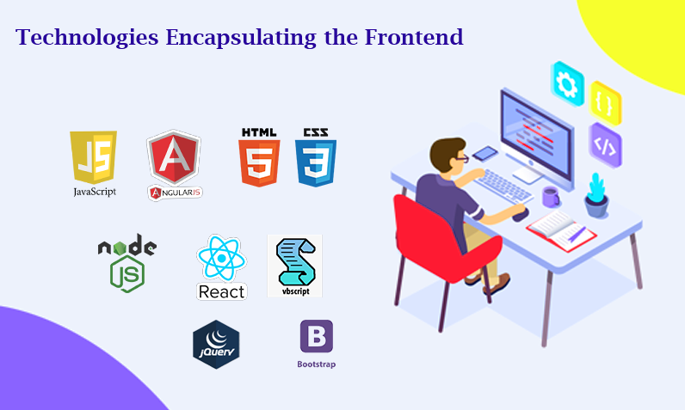

* **Who Are They?**

Frontend developers are the architects of the user experience. They're responsible for everything you see and interact with on a website or web application.

* **What They Do:**

**User Interface (UI) Design:** They design the layout, look, and feel of the application. This includes creating buttons, forms, menus and overall visual aspects.

**User Experience (UX):** They ensure the app is easy to navigate and understand. They focus on making the user's interaction smooth and intuitive.

* **Coding with HTML/CSS/JavaScript:**

**HTML (Hypertext Markup Language):** This is the backbone of a web page, defining its structure and content.

**CSS (Cascading Style Sheets):** CSS is used to style HTML elements, making them visually appealing.

**JavaScript:** They use JavaScript to add interactivity to the website. It's what makes elements on the page respond to user actions (like clicking a button).

**Responsive Design:** They make sure the application works well on various devices (desktops, tablets, phones) by using responsive design techniques.

**Testing:** They conduct tests to ensure the website works across different browsers and devices.

* **Tools They Use:**

**Text Editors:** Tools like Visual Studio Code, Sublime Text, or Atom for writing code.

**Frameworks/Libraries:** Libraries like React, Angular, or Vue.Js for building interactive user interfaces.

**Design Tools:** Programs like Adobe XD, Sketch or Figma for designing the user interface.

* **Applications They Work On:**

Social Media Platforms: Facebook, Twitter, Instagram, etc.

E-commerce Websites: Amazon, eBay, Etsy, etc.

Online Banking Interfaces: Chase, Bank of America, PayPal, etc.

News Websites: CNN, BBC, The New York Times, etc.

Gaming Websites/Apps: Online games, puzzles, interactive experiences, etc.

**BACKEND DEVELOPERS:**

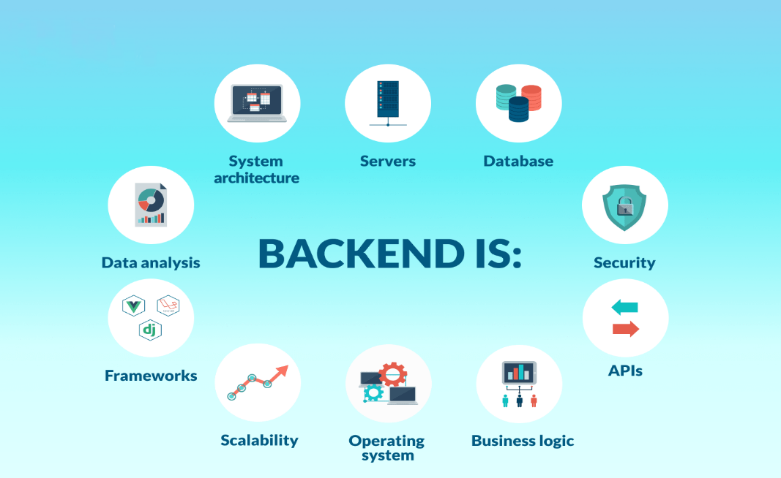

* **Who Are They?**

Backend developers are the "behind the scenes" magicians. They work on the server-side of the application, dealing with data storage, processing, and logic.

* **What They Do:**

**Server-side Logic:** They write code that runs on the server. This code deals with tasks like processing form data, handling user authentication, and communicating with databases.

**Database Management:** They design and maintain databases (like MySQL, PostgreSQL, MongoDB). This is where all the app's data is stored.

**API Development:** They create APIs (Application Programming Interfaces) that allow the frontend and backend to communicate. APIs define how data can be requested and exchanged between different systems.

**Security:** They implement security measures to protect the application from cyber threats. This includes encryption, data validation, and access controls.

**Performance Optimization:** They optimize the application's performance, ensuring it runs smoothly and efficiently.

**Testing and Debugging:** They conduct tests to ensure the server-side code works as expected, and they debug issues that arise.

* **Tools They Use:**

**Programming Languages:** Java, Python, Ruby, Node.Js, etc., depending on the project requirements.

**Frameworks:** Django, Flask, Spring Boot, Express.Js, etc., to speed up development and manage tasks.

**Databases:** MySQL, PostgreSQL, MongoDB, etc., for storing and retrieving data.

**API Tools:** Tools for creating and testing APIs, like Postman.

**Applications They Work On:**

**Content Management Systems (CMS):** WordPress, Drupal, Joomla, etc.

**Enterprise Resource Planning (ERP) Systems:** SAP, Oracle ERP, Microsoft Dynamics, etc.

**Customer Relationship Management (CRM) Systems:** Salesforce, HubSpot, Zoho CRM, etc.

**E-commerce Platforms:** Shopify, Magento, WooCommerce, etc.

**Online Booking Systems:** Airbnb, Booking.com, OpenTable, etc.

Imagine you're building a restaurant! Here's how front-end and back-end developers work together to make it function:

* **Front-End Developers: The Designers of the Dining Experience**
* **Think of them as the interior designers and decorators of your restaurant.**
* They focus on the visual aspects and user experience of the web application.
* Their job is to make sure it's easy and enjoyable to use, just like a restaurant should be inviting and comfortable.
* **Their tools:** HTML, CSS, JavaScript (programming languages for web design and interactivity).
* **What they build:**
  + Layouts and design of web pages (arranging furniture and decorations).
  + Interactive elements like buttons, menus, and forms (placing menus and ordering systems).
  + Responsiveness to ensure the application looks good on different devices (making sure tables and chairs fit various sized customers).
* **Back-End Developers: The Kitchen Staff of the Web**
* **Imagine them as the chefs and cooks preparing the food in your restaurant.**
* They work behind the scenes, writing the code that makes the web application function.
* They handle the logic and data processing, ensuring everything runs smoothly just like a well-oiled kitchen prepares delicious meals.
* **Their tools:** Programming languages like Python, Java, Ruby (depending on the application's needs).
* **What they build:**
  + The core functionality of the web application (like the recipes and cooking instructions).
  + Database management to store and manage user information and application data (keeping track of orders and inventory).
  + Communication with servers and other systems (coordinating between kitchen staff and suppliers).

**Working Together: A Well-Coordinated Restaurant**

* Front-end and back-end developers collaborate to create a complete web application.
* The front-end developer presents a user-friendly interface built on the functionality created by the back-end developer.
* They work together to ensure a seamless experience, just like the collaboration between the dining area and the kitchen creates a satisfying meal for the customer.

**Examples:**

* **Online Shopping:** Front-end developers design the product pages, shopping cart, and checkout process. Back-end developers handle secure payment processing, inventory management, and order fulfillment.
* **Social-Media:** Front-end developers create the user interface for profiles, news feeds, and posting content. Back-end developers manage user accounts, data storage, and communication between users.

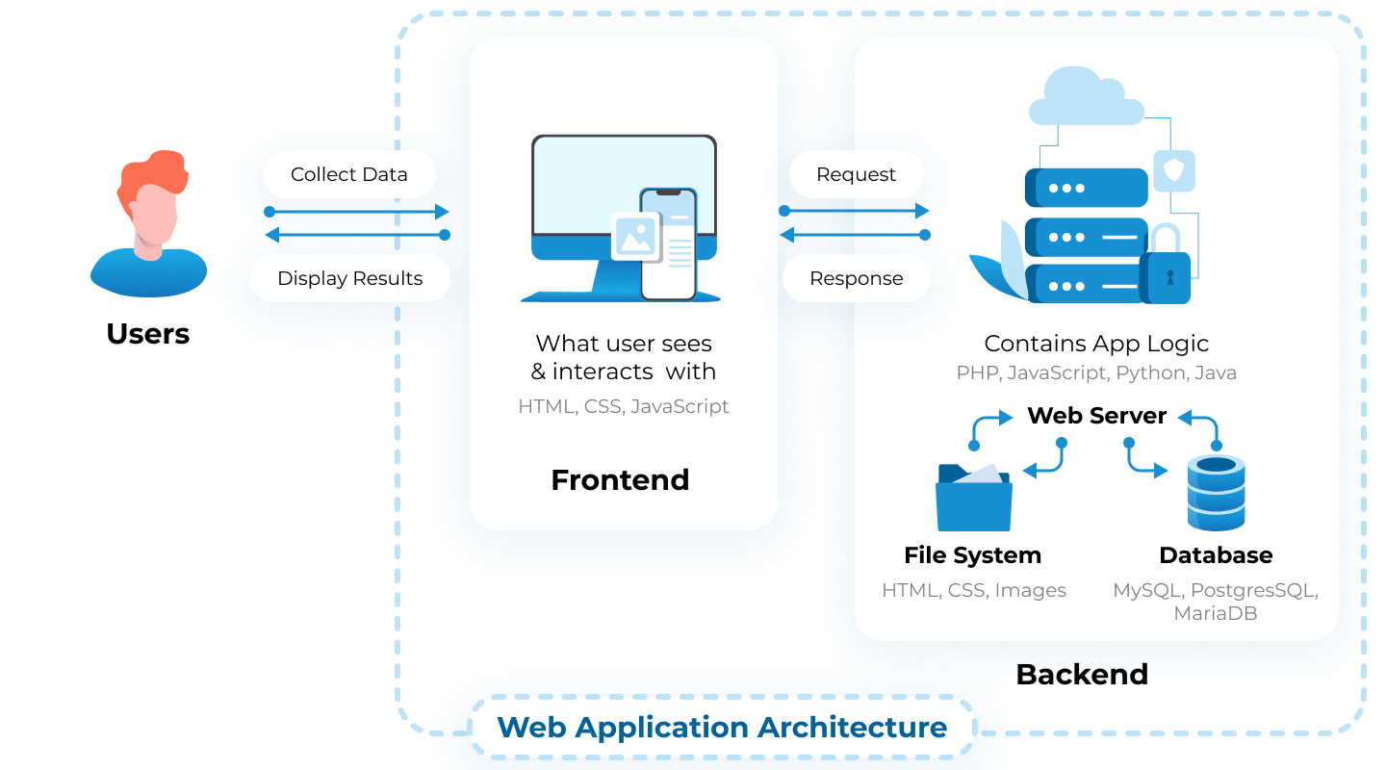

**THREE – TIER ARCHITECTURE**

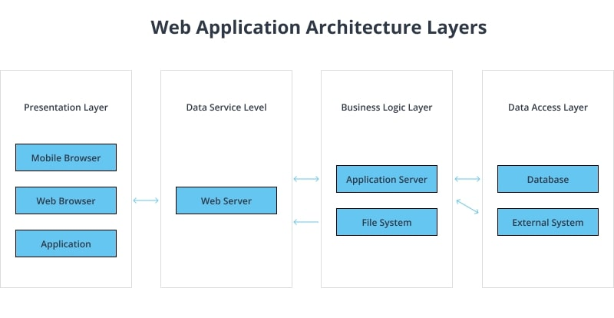

In 3-tier architecture, the application is logically divided into three layers or tiers. Each tier has a distinct responsibility and interacts with the other tiers to form a cohesive system. Let's explore each level in detail:

**Presentation Layer**

**Presentation Tier / Layer :** This is the top layer of the 3-tier architecture and represents the user interface (UI). It's the layer that end-users directly interact with, and it includes everything that the user experiences on their screen: menus, dialogs, display forms, and more. The primary function of this tier is to translate tasks and results to and from the application tier for the user.

Developers can create the Presentation Tier using various technologies, including HTML, CSS, and JavaScript for web applications or native UI frameworks for desktop and mobile applications.

**Key Responsibilities:**

Displaying information to the user

Handling user input and interactions

Sending requests to the application tier for processing

**Application Layer**

The Application Tier, also known as the logic tier, sits between the presentation and data tiers and contains the application's core business logic and rules. This layer executes all functional commands, such as querying the database or processing user input. Developers may implement the Application Tier using server-side languages like Java, C#, Python, etc.

**Key Responsibilities:**

Processing client requests and responding to the presentation tier

Performing business logic and validation

Managing transactions

Communicating with the data tier for CRUD (Create, Read, Update, Delete) operations

**Data Layer**

The Data Tier is the third and final layer, responsible for managing the application's data. This tier consists of databases, file systems, or other data storage systems. It stores, retrieves, and manages data based on requests from the application tier.

Typical technologies used for the data tier include relational databases like MySQL, PostgreSQL, or NoSQL databases like MongoDB.

**Key Responsibilities:**

Storing and retrieving data

Ensuring data consistency and integrity

Handling data transactions and concurrency

In summary, the three tiers of 3-tier architecture work together to deliver a complete application experience. The Presentation Tier handles the user interface, the Application layer processes the business logic, and the Data Tier manages the data. This separation enables greater flexibility, scalability, and maintainability, making it a preferred architecture for many developers and organizations.

Use cases for 3-tier architecture

3-Tier architecture has a flexible and robust design pattern, making it suitable for various applications. Below are some typical use cases where developers often apply 3-tier architecture:

**Web Applications:**In web applications, developers use 3-tier architecture to separate the user interface, server-side logic, and database. This separation allows them to work independently on each tier, improving maintainability and scalability.

**Enterprise Systems:**Large organizations often employ 3-tier architecture in their enterprise systems to ensure a clear division of responsibilities. By isolating business logic from the user interface and data storage, they can achieve better security, flexibility, and manageability.

**E-Commerce Platforms:**E-commerce platforms require a dynamic and robust structure to handle various tasks like product management, user authentication, payment processing, etc. By implementing 3-tier architecture, developers can efficiently manage these complex tasks and ensure a smooth user experience.

**Content Management Systems (CMS):**The 3-Tier architecture supports creating robust content management systems allowing users to manage and organize digital content easily. Developers can independently update or modify the user interface, content processing logic, or storage mechanisms without affecting the other tiers.

**Mobile Applications:**In mobile applications, 3-tier architecture helps manage complex interactions between the user interface, backend processing, and data storage. This architecture provides a clear roadmap for development, promotes code reusability, and simplifies testing.